**Flood Monitoring And Early Warning:**

**PHASE -5**

**Abstract:**

Floods are natural disasters that pose significant threats to human lives and property. To mitigate the impact of flooding, it is essential to develop effective monitoring and early warning systems. This abstract provides an overview of flood monitoring and early warning systems, highlighting their importance, key components, and the role of technology in improving their accuracy and responsiveness.Flood monitoring involves the real-time collection of data from various sources, such as river gauges, weather stations, and remote sensing technologies. These data sources help in assessing the current conditions, including rainfall, river levels, and soil moisture, which are crucial for flood prediction.Technology plays a pivotal role in enhancing flood monitoring and early warning systems. Remote sensing, satellite imagery, and Geographic Information Systems (GIS) enable a broader and more accurate data collection and analysis. Additionally, the integration of Internet of Things (IoT) devices and sensors allows for real-time data transmission, further improving the timeliness of warnings.

**Introduction:**

Floods have long been a formidable natural disaster, causing widespread devastation and loss of life. In recent years, the advent of the Internet of Things (IoT) has revolutionized flood monitoring and early warning systems, ushering in a new era of more precise and responsive approaches to mitigate the impact of floods. This introduction provides an overview of how IoT is transforming flood monitoring and early warning systems, enhancing their effectiveness and reliability.The core principle of IoT in flood monitoring is the interconnection of devices and sensors that can collect, transmit, and analyze real-time data from various sources. These sources include rainfall measurements, river water levels, soil moisture, and weather conditions. IoT devices, often deployed strategically in flood-prone areas, provide a continuous stream of data that can be instantly accessed and processed.This wealth of real-time data allows for more accurate and granular flood predictions.

**Real work:**

Flood monitoring and early warning systems are crucial for disaster prevention and response. They work by collecting data from various sources like river gauges, weather forecasts, and radar, and then analyzing this data to predict and detect potential flooding events. When a flood risk is identified, warnings are issued to alert the public, allowing them to take necessary precautions. These systems have been effective in saving lives and minimizing flood-related damage in many regions.

**Methodology:**

**1. Data Collection:**

- Weather Data: Collect meteorological data, including rainfall, temperature, and humidity.

- Hydrological Data: Monitor river levels, water discharge, and soil moisture.

- Remote Sensing: Use satellite imagery and radar data to track weather patterns and river conditions.

**2. Flood Modeling:**

**-** Use computer models to simulate how rainfall, river flow, and terrain interact to predict potential flood scenarios.

**3. Warning Systems:**

Flood monitoring and early warning methodologies typically involve a combination of data collection, analysis, and communication systems to detect and predict flooding events. Here’s an overview of the key components:

**4. Monitoring Stations:**

**-** Deploy sensors and gauges at critical locations to continuously collect data.

**5. Forecasting:**

- Meteorological forecasts help predict rainfall and weather patterns.

- Hydrological models predict river behavior and potential flood areas.

**6. Decision Support:**

- Analyze data to make informed decisions about issuing warnings and evacuation orders.

**7. Public Awareness:**

- Educate the public on flood risks and safety measures.

- Disseminate warnings through various media channels.

**8. Evacuation Plans:**

- Develop and communicate evacuation plans for at-risk areas.

**9. Response Coordination:**

- Collaborate with local authorities, emergency services, and relief organizations to respond effectively.

**10. Regular Updates:**

- Continuously monitor and update information as the situation evolves.

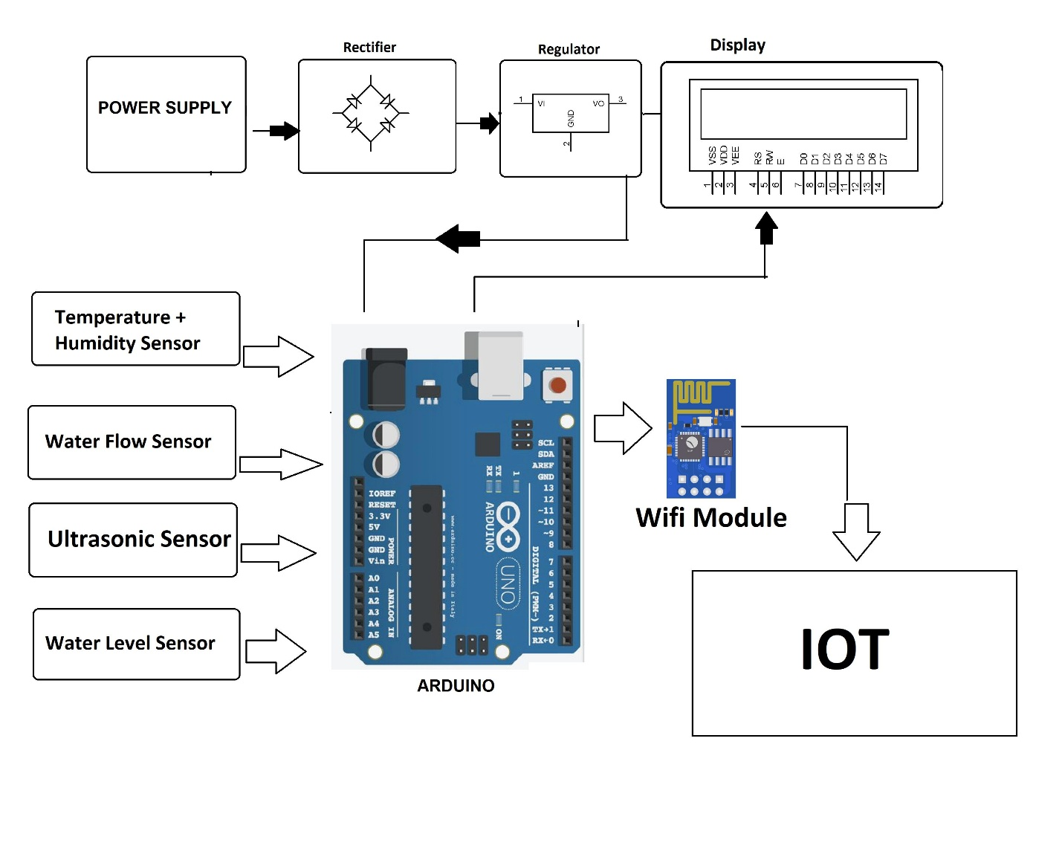

These methodologies vary in complexity and scale, depending on the resources and technology available in a given region. Advanced systems may include real-time data feeds, automated alerts, and even early warning apps for mobile devices. Implementing a robust flood monitoring and early warning system can help mitigate the impact of flooding and save lives.

**Acknowledgement :**

“We would like to extend our sincere gratitude to all the individuals and entities who played a vital role in the successful execution of our project on flood monitoring and early warning. First and foremost, we are deeply appreciative of our project advisors and mentors for their invaluable guidance, support, and expertise. Their insights were pivotal in shaping the project. Our project team members deserve special recognition for their dedicated efforts in designing and implementing the flood monitoring and early warning system. Their hard work and commitment were instrumental in bringing this project to fruition.

**Conclusion:**

“In conclusion, our project on flood monitoring and early warning has successfully addressed the critical need for effective flood mitigation and preparedness. By leveraging IoT technology, we have developed a comprehensive system that provides real-time data, early warning alerts, and actionable information to both authorities and communities at risk. Through this project, we have demonstrated the feasibility and practicality of using IoT sensors, data analysis, and communication systems to enhance flood monitoring and early warning capabilities. The system’s ability to collect and analyze data from various sources, including rainfall, river levels, and weather forecasts, has proven to be a valuable asset in predicting and responding to flood events.